**Explanation:** This lab will explain how to transform text using the GDI+ Feature with Visual Basic. We will have one window that will show the text in its untransformed state and another window with the text being transformed with a GDI+ subroutine.

**Goal: Transform text with GDI+.**

**Required Controls:** Two (2) windows forms, One (1) MenuStrip on each form.

**Step 1)**

* Create a Windows Form Project.
* Rename form1 as dfltText
* Change the text of form1 to Default Text.
* Add the MenuStrip control to the windows form. Make the main MenuStrip dropdown text “File”. Under “File” make the submenu items “Transformed Text” and “Exit”.
* The window should show up as:

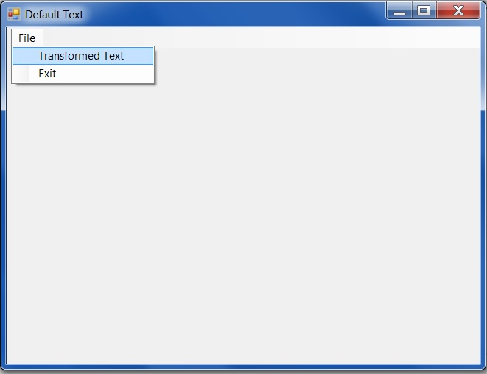

* Add a second form to the project.
* Rename this form to transText and change the Text of the form to “Transformed Text”.
* Add a MenuStrip control to the form. Set the MenuStrip up the same as the MenuStrip on Form1.

**Step 2)**

* On the first form, open the “File” drop down on the MenuStrip and double click on the “Transformed Text” Menu Item.
* Add the following code snippet:
* Go back to the same form and double click on the “Exit” Menu item.
* Add the code snippet to Close the form:

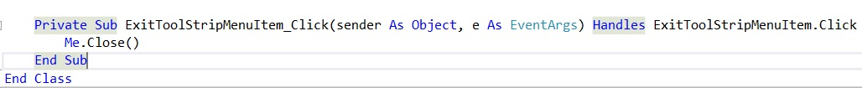

* The second windows form will follow the same steps with one exception. The “Exit” code snippet will include closing both windows form. This added function closes the application out entirely instead of having to navigate back to the first windows form and closing out the application from that window. The code will be:

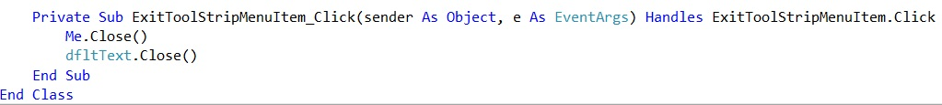

**Step 3)**

Now we will be setting up the project to utilize the GDI+ function of the Visual Studio Environment. GDI+ stands for Graphics Design Interface and allows us to create graphics, draw text, and manipulate premade graphics all within the coding of our visual basic project.

* We are going to set up the code that will allow us to transform text using GDI+ features.
* The following is the subroutine that allows us to transform the text with the GDI+ features:

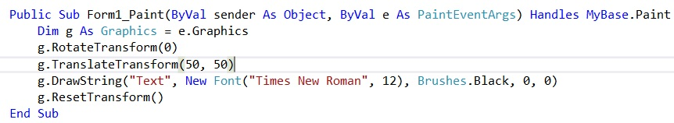

* This is an example of a default state for text. With this subroutine, we can start to change any one of the parameters and see a change in the text. With the parameters above this is what the text will look like:

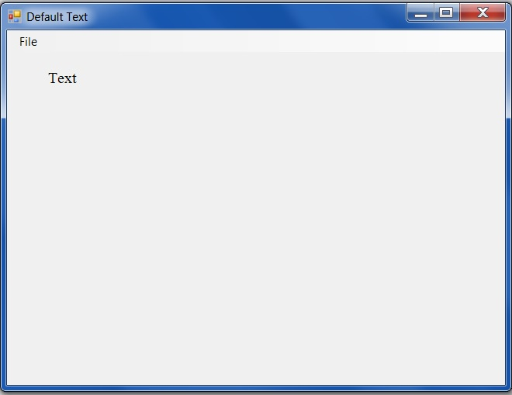

* Leave all of the parameters the same in the code except for the text line. Change the code to reflect this snippet:

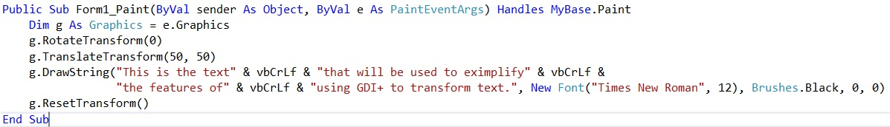This will give a little more text to see the effects of the transformation.

* Copy the same code into the second form in the project.
* Next, change the pieces of code that transform the text. For this example, I’ve use the following changes to transform the text:

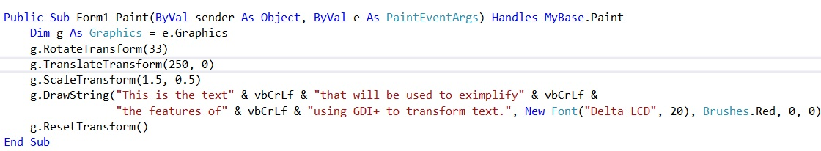

* As you can see in the code above, there was a line added called “g.ScaleTransform”. This section stretches, compresses, lengthens or shortens the text.
* These changes in code will result in the text looking like this:

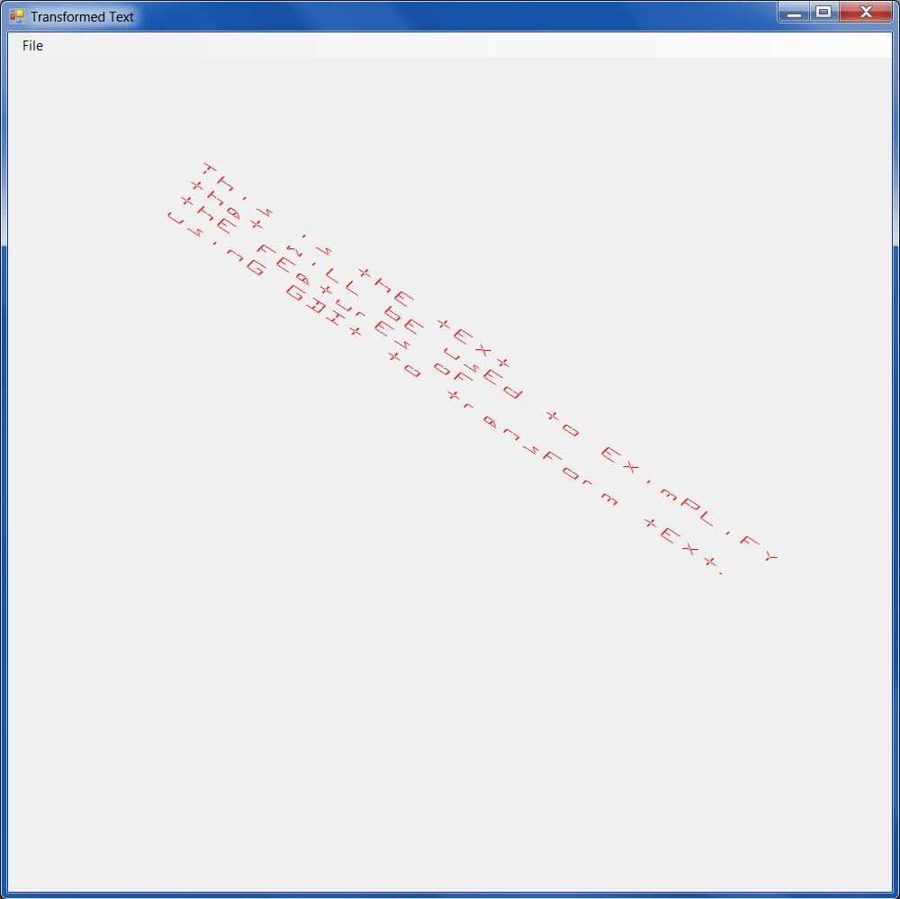

* Using GDI+ subroutine in this example you can choose any font, color, font size, change the rotation, scale, and rotation of the text you input.